**Jake Greenberg HW 3**

**Control Flow and Data Flow Charts**

**Control Flow**

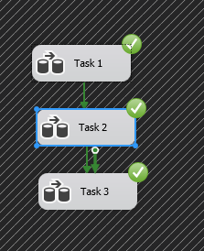

**Task 1 Data Flow**

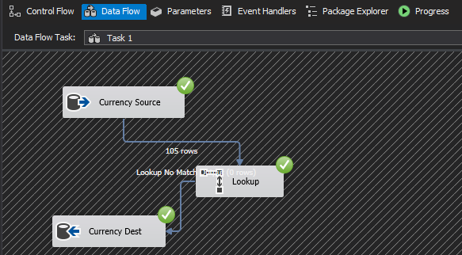

Task 1 completes with no issues. A lookup is used to prevent duplicate entries from being added in successive runs. We have 105 unique types of currency classifications.

**Task 2 Data Flow**

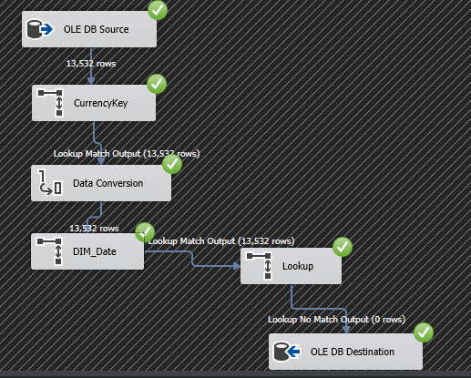

I worked with Dr. Shi on Task 2 to get it working. We can see here a run where it’s already been added to the table (hence the Destination receiving 0 new rows)

We create the Currency Key, and then modify the Date table from the non-DW to match the format we need. We then send everything to a lookup for sorting, at which point it will be sent to the destination, so long as it is not a duplicate row. (Same composite key).

**After working with Dr. Shi, Task 2 is fully functional. A lot of it had to be rebuilt from scratch.**

After working on Task 3, I was unable to properly incorporate the SCD. I plan to work on this later after finals, purely due to my own curiosity.

**

**Task 2 Screenshot**

